**Week6 React HandsOn**

**1. ReactJS-HOL**

Create a new React Application with the name “myfirstreact”, Run the application to print “welcome to the first session of React” as heading of that page.

Folder Structure

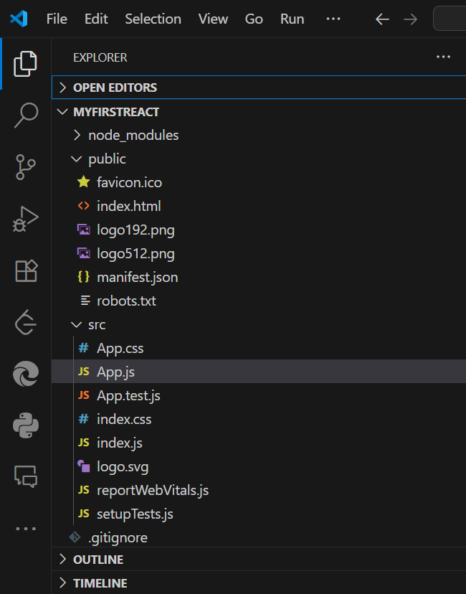

**App.js**

function App() {

  return (

    <h1>Welcome to the first session of react</h1>

  );

}

export default App;

**Output:**

PS C:\Users\umaya\Desktop\-Cognizant-Nurture-4.0-practice\Week6\myfirstreact> npm start

> myfirstreact@0.1.0 start

> react-scripts start

